RD Fresh: 100% Natural Refrigeration Dehumidifiers
Be Part of the Solution, Keep Food Fresher Longer, Save Energy, Save Money ¹

Product Overview
RD Fresh is a 100% natural mineral mix (Zeolites) engineered to optimize commercial refrigeration. By managing humidity and air quality, it enhances efficiency, ensures food safety, and significantly reduces operational costs.Key Benefits

Operational Savings
- Energy Efficiency: Reduces refrigeration energy costs by up to 10%⁴.
- Equipment Life: Extends compressor life by reducing refrigeration cycles by up to 50%⁵.
- Temperature Control: Helps lower internal temperatures by 3-5 degrees⁶.

Food Safety & Quality
- Extended Shelf Life: Increases the shelf life of food products by up to 50%.
- Humidity Control: Absorbs up to 55% of its weight in humidity.
- Hygiene: Reduces bacteria, cross-contamination, and the transfer of food odors.

Environmental Impact
- Sustainability: A "Zero Footprint" product that is 100% natural and completely recyclable.

Berry Test: Mold & Yeast Reduction
RD Fresh reduced mold and yeast counts by 2x to 3x compared to untreated environments.
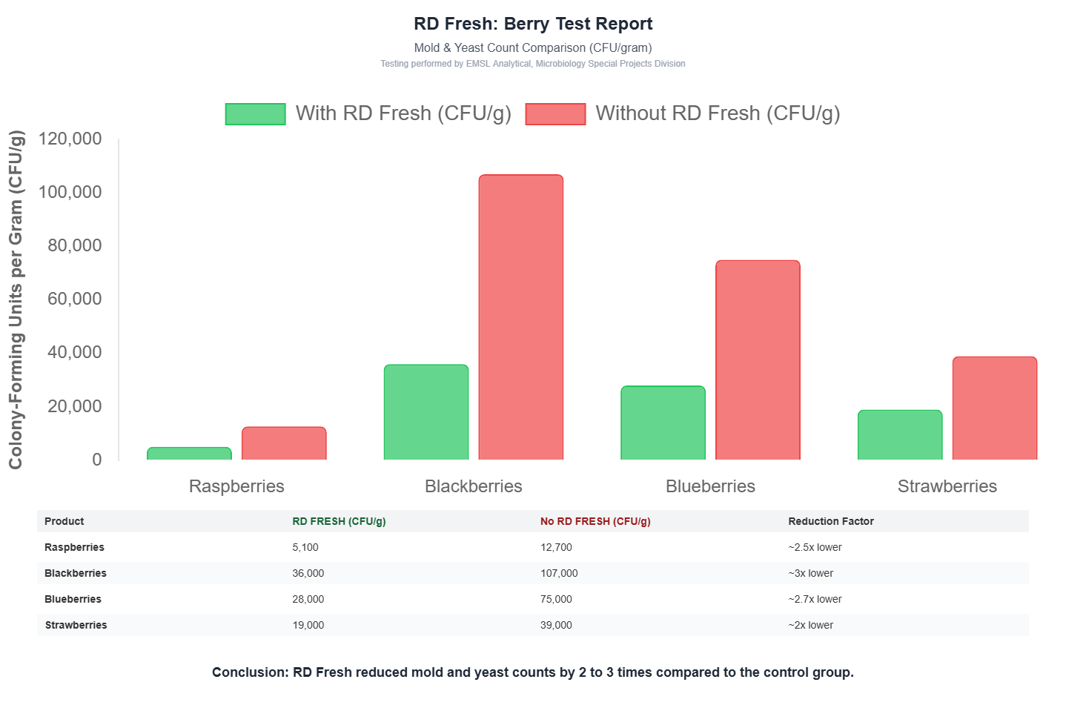

Product | With RD Fresh | Without RD Fresh | Reduction Factor
Blackberries | 36,000 CFU/g | 107,000 CFU/g | ~3x lower ¹³
Blueberries | 28,000 CFU/g | 75,000 CFU/g | ~2.7x lower ¹⁴
Raspberries | 5,100 CFU/g | 12,700 CFU/g | ~2.5x lower ¹⁵
Strawberries | 19,000 CFU/g | 39,000 CFU/g | ~2x lower ¹⁶

Ground Beef: Bacteria Proliferation
RD Fresh reduced Aerobic Plate Counts (APC) by almost 50%.

- Day 1: 2.46x rise in APC (vs. 8.50x without RD Fresh).
- Day 4: 7.92x rise in APC (vs. 15.25x without RD Fresh.

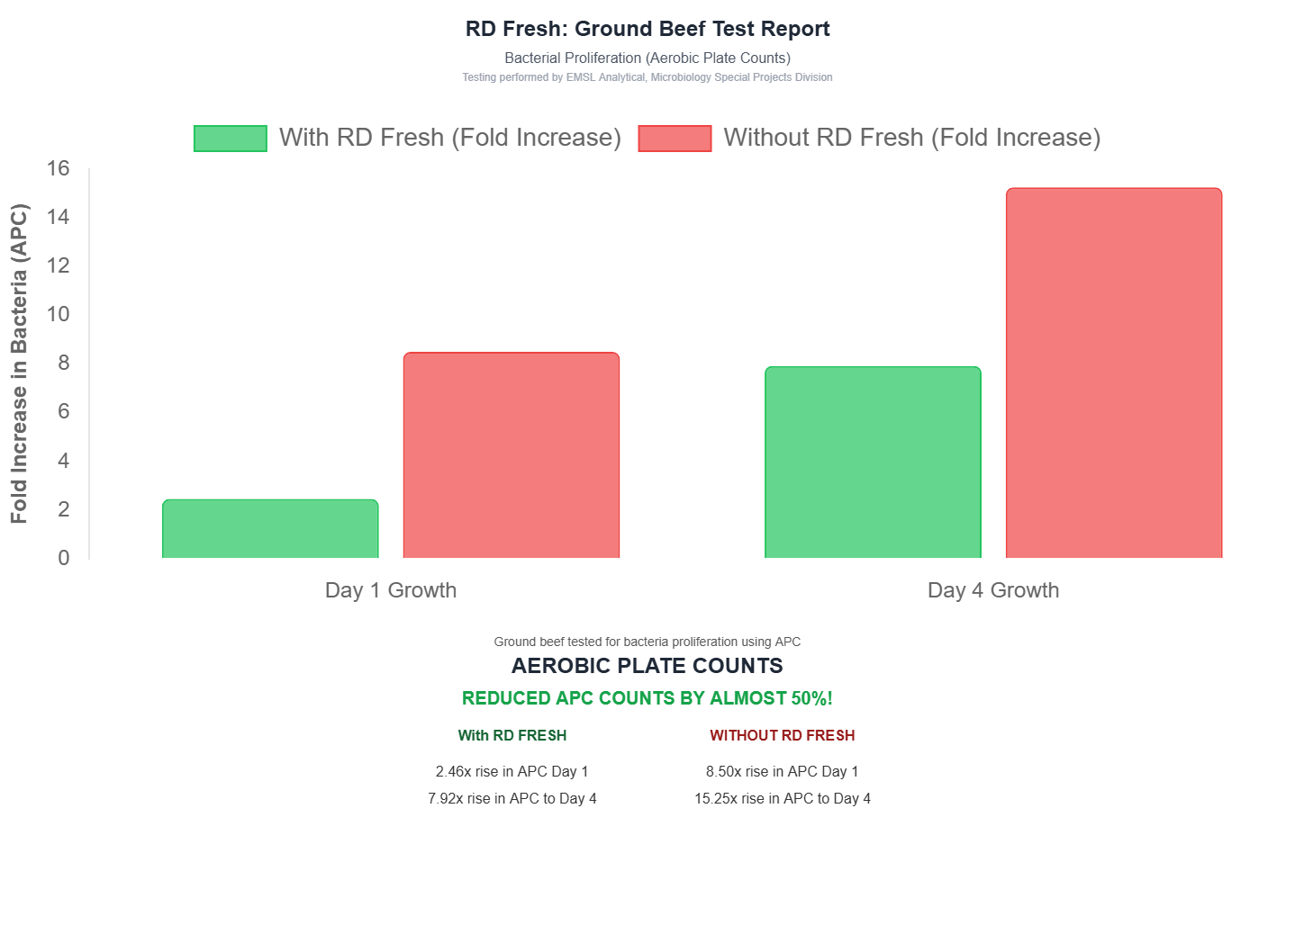

- Validated Laboratory Results
Testing performed by EMSL Analytical confirms the efficacy of RD Fresh in controlling microbial growth

